Web Programming Final Project

Chris Mazurski

Phu Phan

CS 416-01

Professor Williams

12/05/16

Instructions

* A user can make a new account and login by hitting Sign Up, or use their existing account to Log In
* On login, a user recieves an updated navbar with options to view/edit user details, and the option to logout and kill the session.
* A user can view products up for sale by hitting the Products button
* A user can find products using the search bar
* Adding products to the cart will update both the number of products and the cost of them in the navbar via AJAX.
* Clicking the cart will allow the user to see exactly which products they’ve stashed for the order, and update/delete them from the cart as they wish
* In order to reach the checkout view, the user must be logged in (and will be sent to the login page if they haven’t done so)
* Checkout will provide the user with a list of exactly what’s in their order (including quantity), and the grand total.
* Logging in via username: [adminuser@adminuser.org](mailto:adminuser@adminuser.org) and password:adminuser will provide extra features in the pages, such as the ability to add,delete, and edit products in the product view, as well as the ability to delete user accounts.

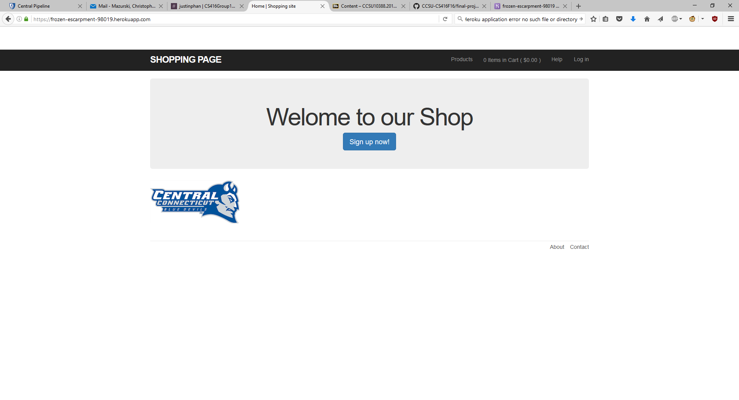

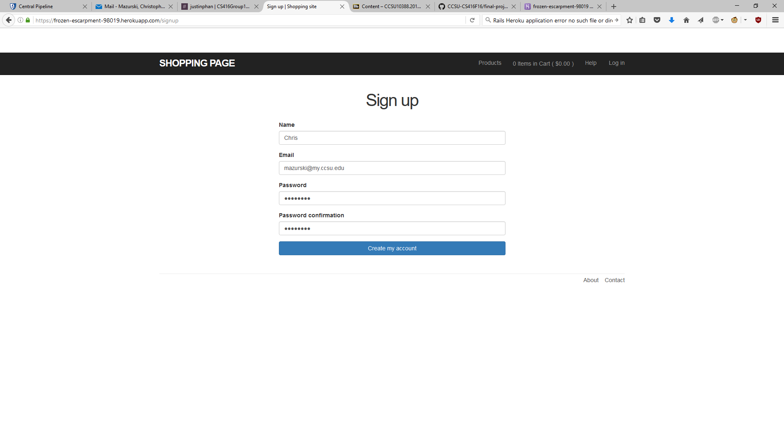

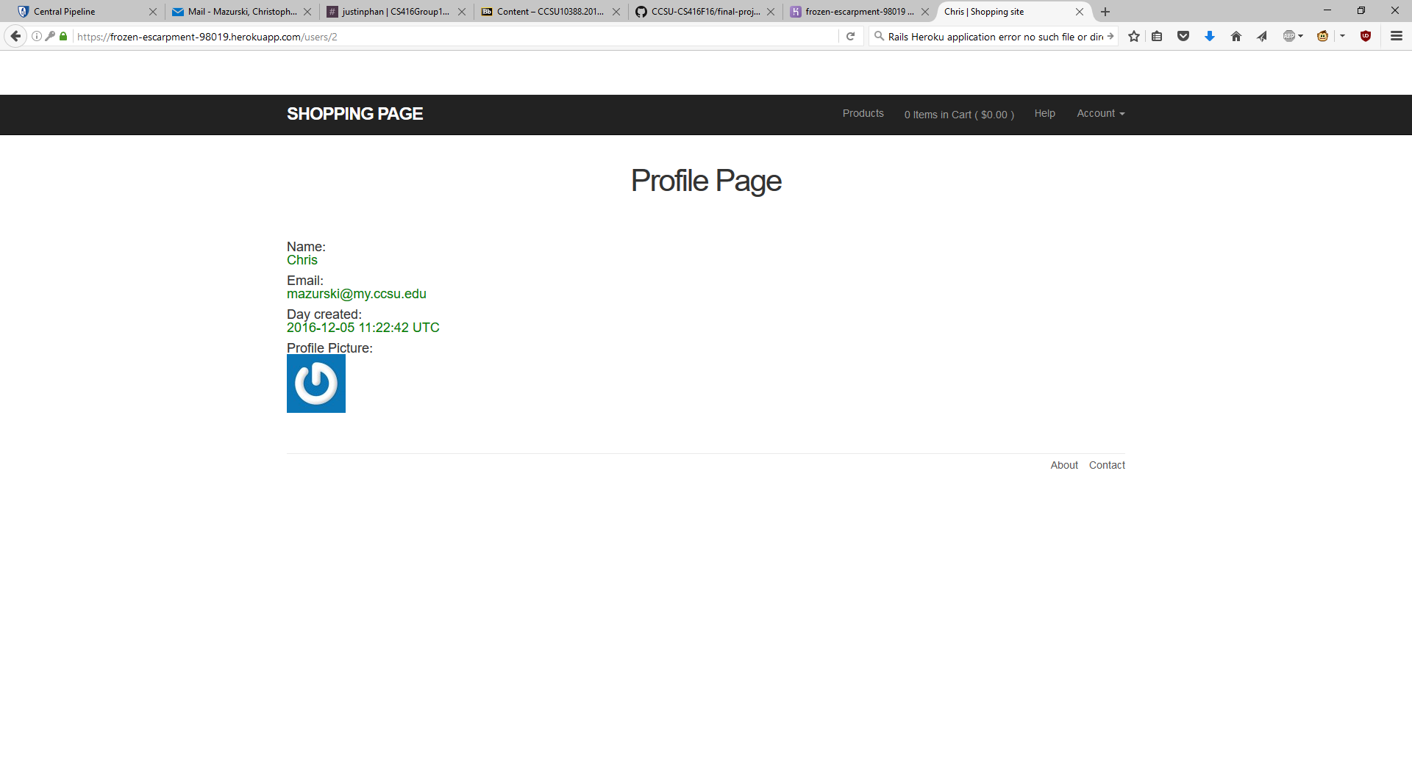

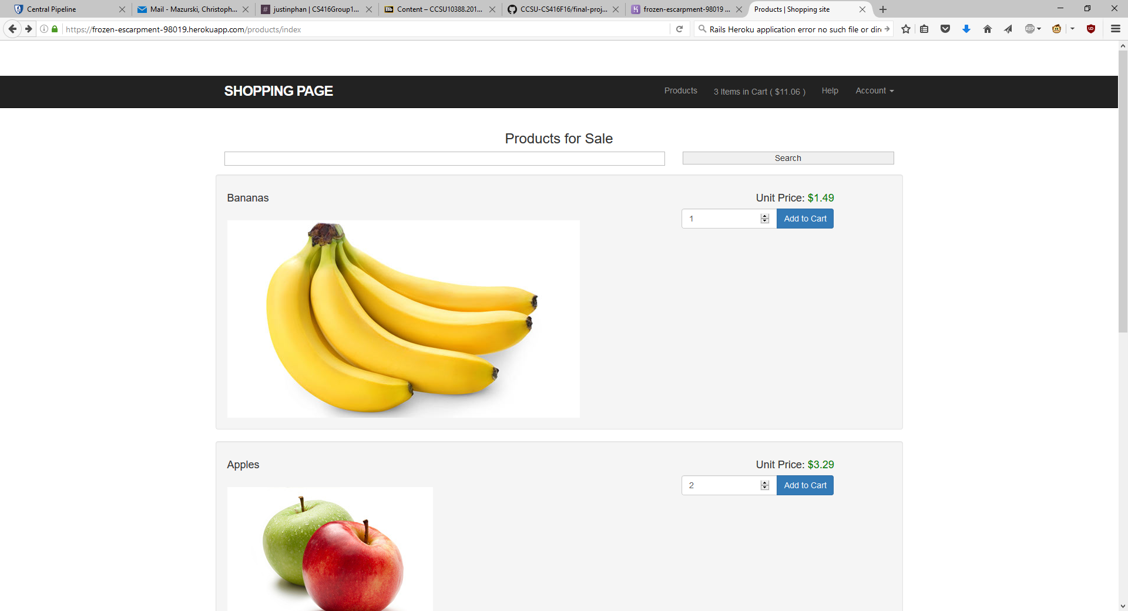

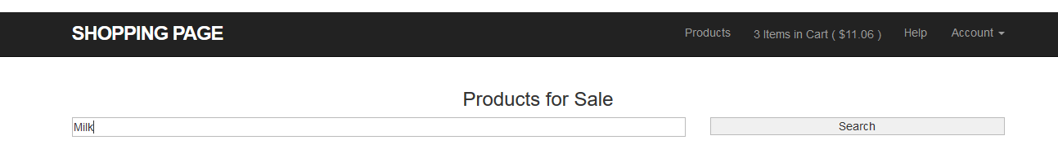

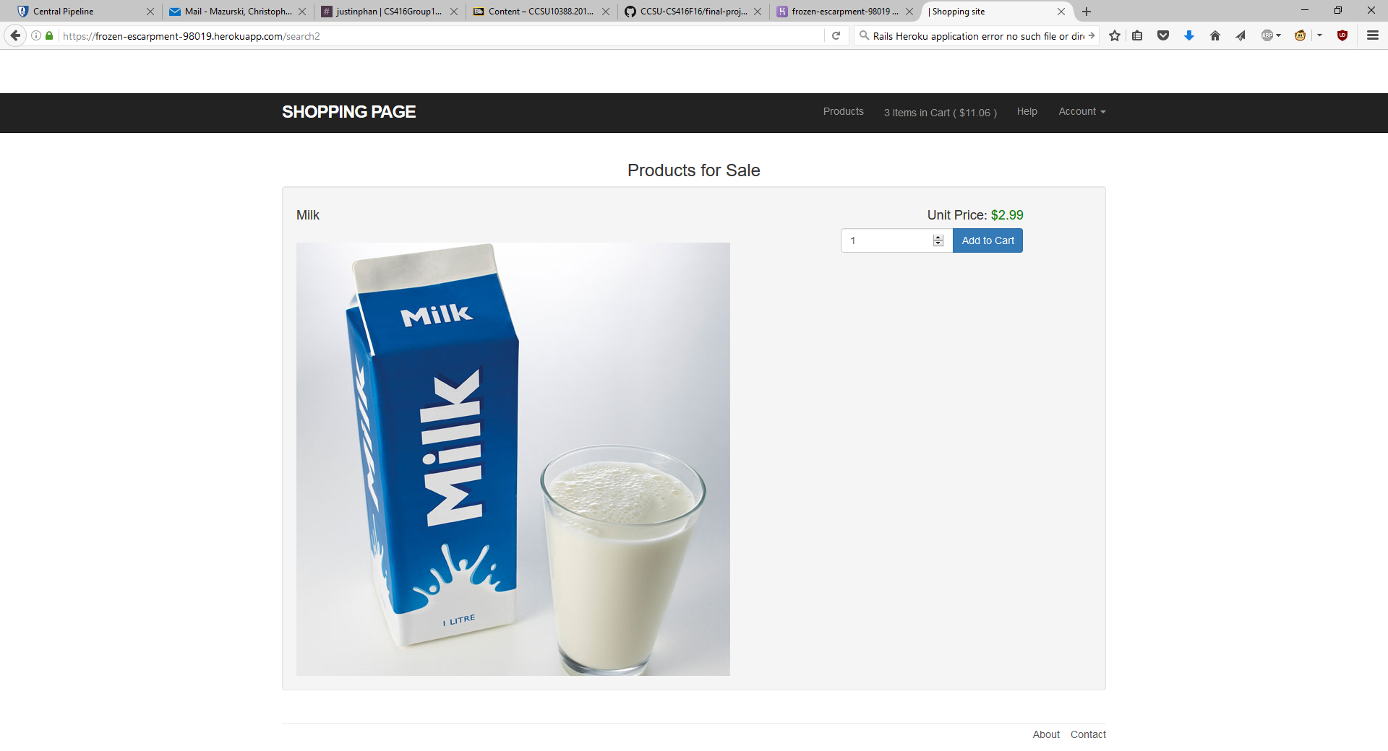

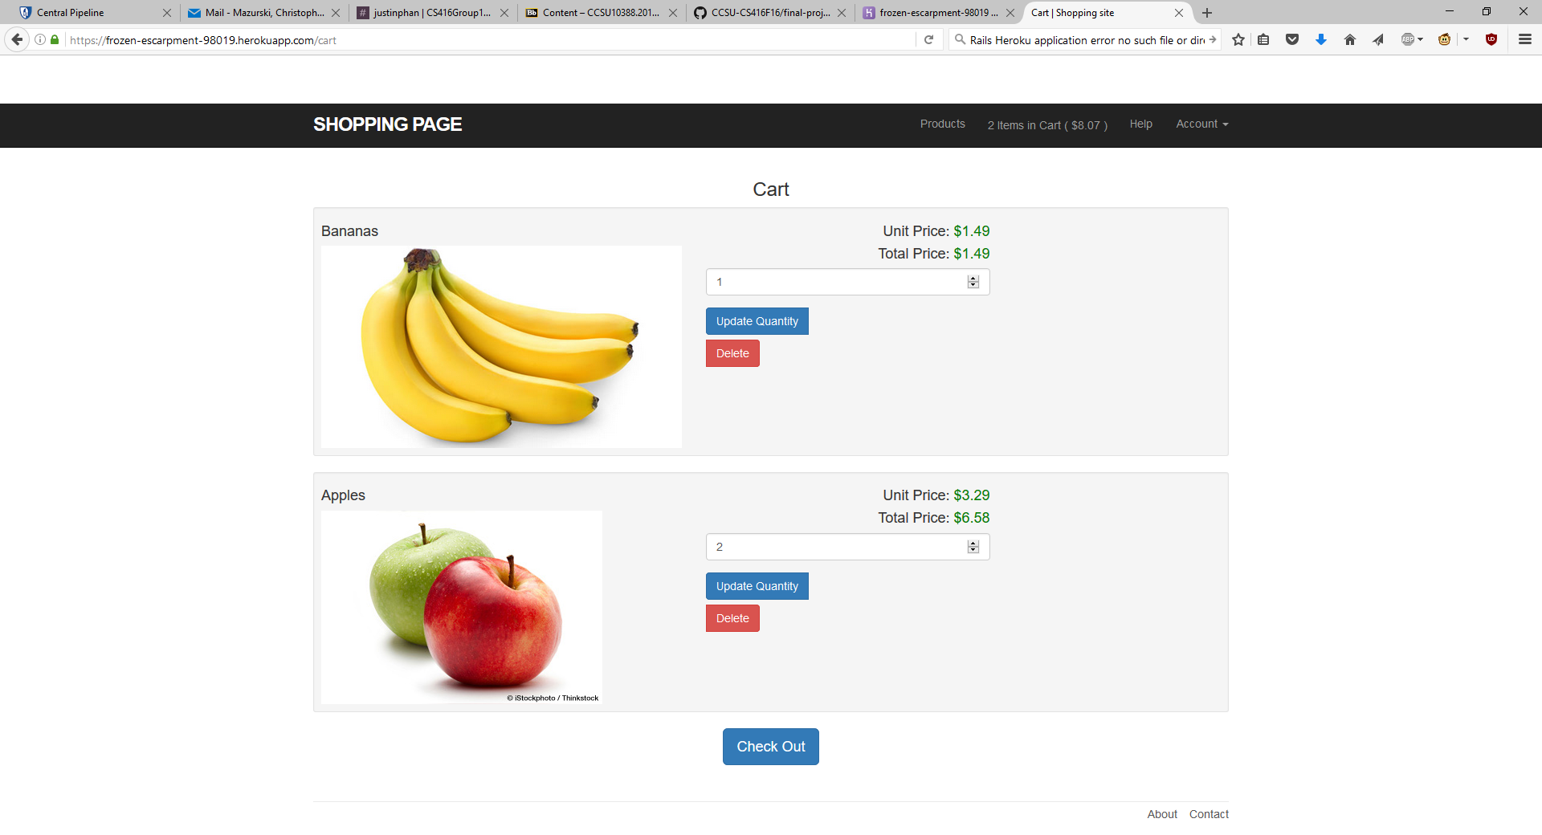

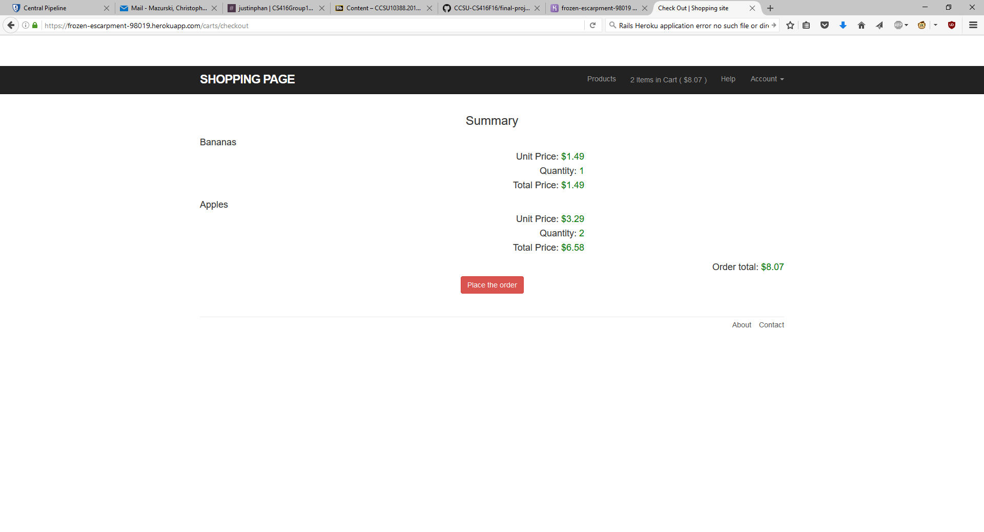

**Admin views**

